ConsensusDocs® 262
BID BOND

GENERAL INSTRUCTIONS. These instructions are solely for the information and convenience of ConsensusDocs users, and are not a part of the document. Gray boxes indicate where you should click and type in your project information. The yellow shading is a Word default function that displays editable text and is not necessary for document completion. Shading can be turned off by going to the Review tab, select “Restrict Editing” button and uncheck “Highlight the regions I can edit”. In Word 2003 you will find this option under the Tools tab, Options, Security tab, Protect Document button.

EMBEDDED INSTRUCTIONS are provided to help you complete the document. To display or hide instructions select the “¶” button under the “Home” tab to show all formatting marks. Instruction boxes are color coded as follows:

Red Boxes: Instructions for fields that are typically required to complete contract.
Blue Boxes: Instructions for fields that may or may not be required for a complete contract.
Green Boxes: Provide general instructions or ConsensusDocs Coalition Guidebook comments, which can be found at www.ConsensusDocs.org/guidebook.

ENDORSEMENT. This document was developed through a collaborative effort of organizations representing a wide cross-section of the design and construction industry. The organizations endorsing this document believe it represents a fair allocation of risk and responsibilities of all project participants.

Endorsing organizations recognize that this document must be reviewed and adapted to meet specific needs and applicable laws. This document has important legal and insurance consequences, and it is not intended as a substitute for competent professional services and advice. Consultation with an attorney and an insurance or surety adviser is strongly encouraged. Federal, State and Local laws may vary with respect to the applicability or enforceability of specific provisions in this document. CONSENSUSDOCS SPECIFICALLY DISCLAIMS ALL WARRANTIES, EXPRESS OR IMPLIED, INCLUDING ANY WARRANTY OF MERCHANTABILITY OR FITNESS FOR A PARTICULAR PURPOSE. PURCHASERS ASSUME ALL LIABILITY WITH RESPECT TO THE USE OF THIS DOCUMENT, AND CONSENSUSDOCS AND ANY OF THE ENDORSING ORGANIZATIONS SHALL NOT BE LIABLE FOR ANY DIRECT, INDIRECT OR CONSEQUENTIAL DAMAGES RESULTING FROM SUCH USE. For additional information, please contact ConsensusDocs, 2300 Wilson Blvd, Suite 300, Arlington, VA 22201, 866-925-DOCS (3627), support@consensusdocs.org or www.ConsensusDocs.org.
ConsensusDocs® 262

BID BOND

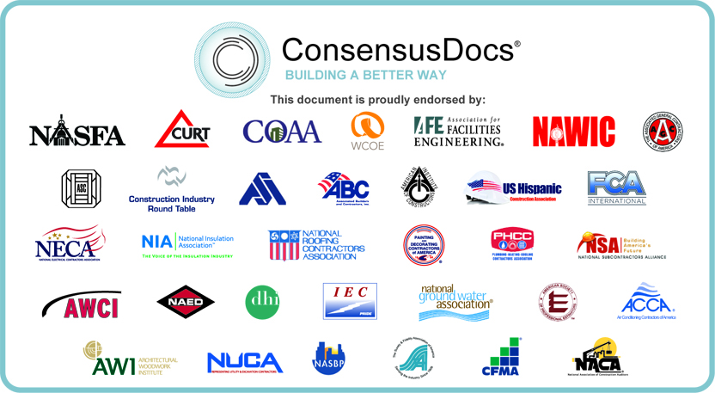

The Contractor, , (the "Contractor") has submitted a Bid to the Owner, , (the "Owner") for the (the "Project") in accordance with the Bidding Documents, including Drawings and Specifications prepared by (the "Design Professional").

By virtue of this Bid Bond (the "Bond"), the Contractor as Principal and as Surety ("Surety"), are bound to the Owner as Obligee in the maximum amount, Dollars ($) (the "Bond Sum"). The Contractor and Surety hereby bind themselves, their heirs, executors, administrators, successors and assigns, jointly and severally, as provided herein.

- If the Obligee shall accept the bid of the Contractor, the Contractor shall enter into an Agreement with the Obligee in accordance with the terms of such Bid.

- Contractor shall procure such bond or bonds as are specified in the Contract Documents for the faithful performance of the Work and for the prompt payment of labor and materials furnished in the performance of the Work.

- If the Contractor fails to enter such Agreement and give such bonds, the Contractor shall pay to the Obligee the difference between the amount of Contractor's bid and the amount of such agreement the Obligee in good faith executes with another Party to perform the Work covered by Contractor's Bid, not to exceed the Bond Sum stated above.

- If the Contractor shall fulfill its obligation under Articles 1 through 3, then this obligation shall be null and void; otherwise it shall remain in full force and effect.

This Bond is entered into as of (date)

SURETY: (seal)

BY:

Print Name: Print Title:

(Attach Power of Attorney)

Attest:

(Additional signatures, if any, appear on attached page)

Contractor: (seal)

BY:

Print Name: Print Title:

Attest:

(Additional signatures, if any, appear on attached page)

END OF DOCUMENT.

